REQUEST FOR LETTERS OF INTENT

Molycorp is requesting Letters of Intent from qualified university researchers and research groups for the purpose of investigating the potential effect of chemical and physical weathering on stability of rock piles at its molybdenum mine located near Questa, New Mexico. The ultimate goal is to develop a model to assess the risk of physical failure of existing mine rock piles based on the physical, chemical, and mineralogical composition and weathering of the rock. Judging from the qualifications of these individuals and/or groups, Molycorp will invite selected university researchers and research groups (which can include qualified non-university research scientists) to visit the mine site in November 2002, and subsequently submit a Research Proposal to the Company within two months after the mine visit. If warranted, more than one proposal could be accepted and research teams could be organized. This multi-year research, which will be fully funded by Molycorp with the possibility of renewal, should focus on aspects of understanding the weathering processes and the effect, or influence, of these processes on the overall stability of the rock piles. Research proposals will be selected in February 2003. The research is to begin not later than 1 June 2003. Molycorp and its consultants will provide oversight on the project or projects.

Basis of Request

Pursuant to the New Mexico Mining Act of 1993, the State of New Mexico Mining and Minerals Department (MMD) requires that operating mines submit closure plans for the purpose of obtaining a permit to continue operation. Molycorp Inc., in cooperation with MMD, and other stakeholders have formed an Independent Mine Rock Pile Stability Review Board (the “Board”) of experts to assess the current and potential future risks associated with the mine rock piles relative to stability at Molycorp’s Questa mine in Taos County, New Mexico. This Board convened in 2001 and has thus far submitted two reports and answers to comments from the stakeholders reviewing existing conditions and on-going studies.

Although rock pile engineering investigations are well under way, investigations into the geochemical and physical weathering effects over time on mine rock pile fabric, water movement through piles, and mechanical properties are yet to be designed and initiated. Molycorp believes that additional work should be conducted relative to geochemical and physical-weathering studies proposed by the Board. To this end, Molycorp will solicit from qualified university scientists research proposals for multi-year, fully funded research programs, with the possibility of renewal, to study the impacts of acid rock weathering and the relationship of this weathering to stability in its Questa mine rock piles. Qualified non-university research scientists should partner with a university-led research team. If warranted, more than one proposal could be accepted and research teams could be organized. Molycorp and its consultants will provide oversight on all research conducted on Molycorp-related projects.

Quarterly reports are to be submitted to the company throughout the funding period and until receipt of final reports/theses. Semi-annual review meetings to evaluate research progress will be coordinated through an Acid Drainage Technology Initiative-Metal Mining Sector (ADTI-MMS) technical research review panel. All research proposals must contain a schedule for deliverables. Pertinent background information, past and on-going and future work, a research task list, resources available to researchers, and on-site specific references are presented, below. Either all or part of the research task list may be addressed in a submitted proposal.

Letters of Intent which state the researcher’s qualifications, available research facilities, research interests, etc. (see Letter of Intent, below) must be postmarked not later than 11 October 2002.

Background

Location. The Questa molybdenum mine is located on the western slope of the Taos Range of the Sangre de Cristo Mountains, Taos County, Northern New Mexico (Figure 1). The mine offices are accessible from State Highway 38, 3.5 miles east of the intersection between state highways 522 and 38 in the town of Questa. It follows the Red River valley and connects the mine with Questa to the west and the town of Red River some 12 miles to the east. The mine is an underground molybdenum disulfide (“moly”) mine that
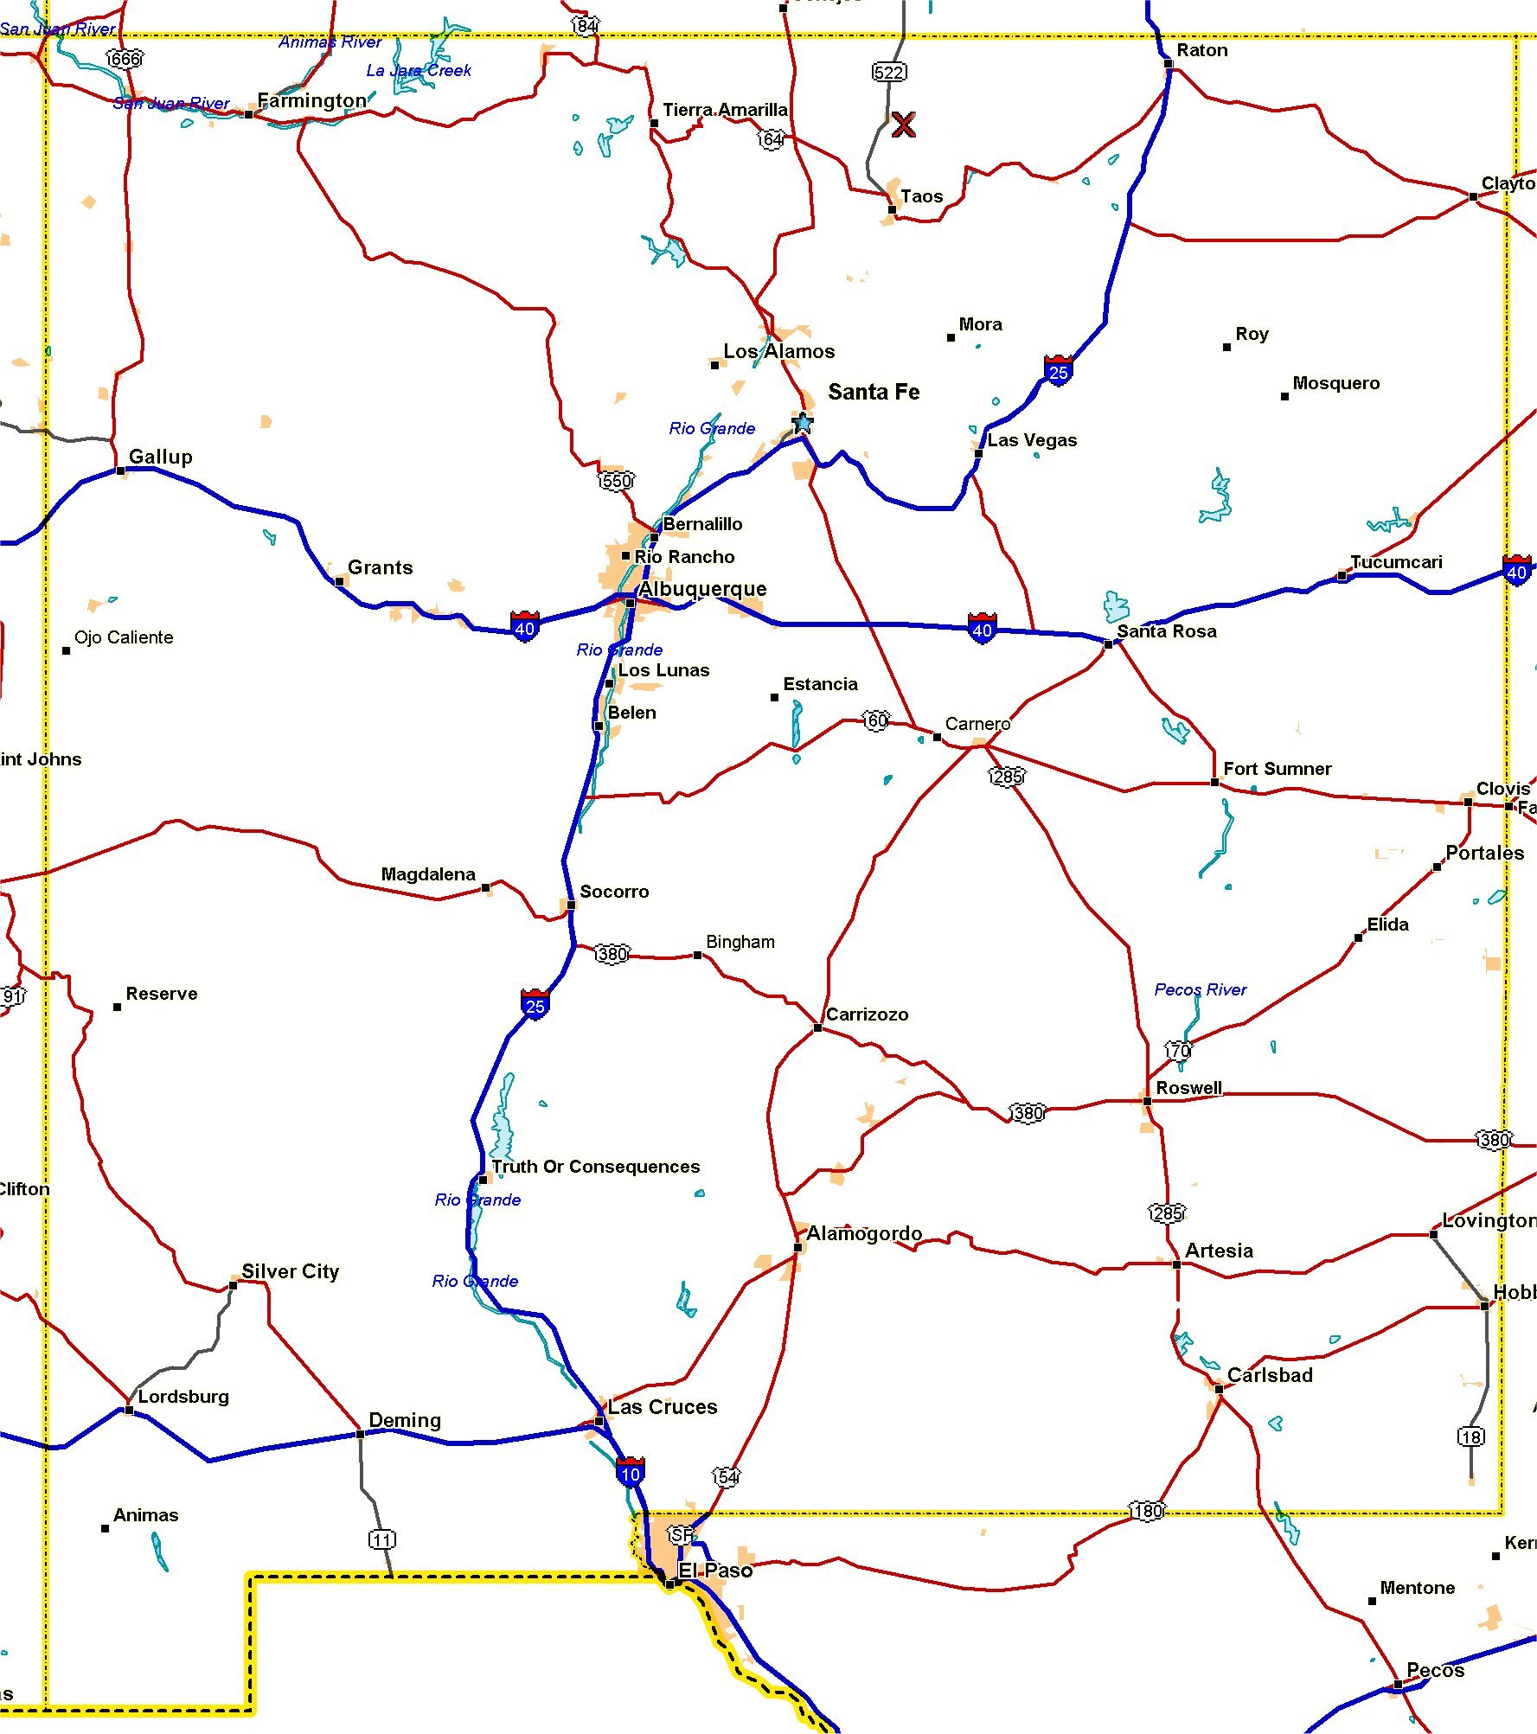
currently uses a block caving mining method to extract ore.
Molycorp
Figure 1 – Map showing Questa mine location.

Mine History. The Molybdenum Corporation of America began mining and concentrate production with a converted gold mill in 1919. In 1923, a mill (40 TPD capacity) and camp was built at the current mill site. High-grade lode veins were mined until 1958. Grades averaged 4 % MoS₂ with some lodes as high as 35 % MoS₂.

Open pit development began in Sulfur Gulch in 1965. Pit production began in 1969, and the mill capacity at this time was 15,000 TPD. Peak production was attained in 1976 when 11.5 million pounds of MoS₂ was packed into containers. When pit production was halted in 1981, some 81 million tons of ore had been processed at an average grade of 0.185 % MoS₂. During the open pit period of mining some 350 million tons of overburden rock were stripped and deposited onto mountain slopes and into tributary valleys (Figure 2).

Underground development of block caving production levels and electric haulage began with decline mining and shaft sinking in 1979. Underground production commenced in 1983 and continues to this day. Current production stands
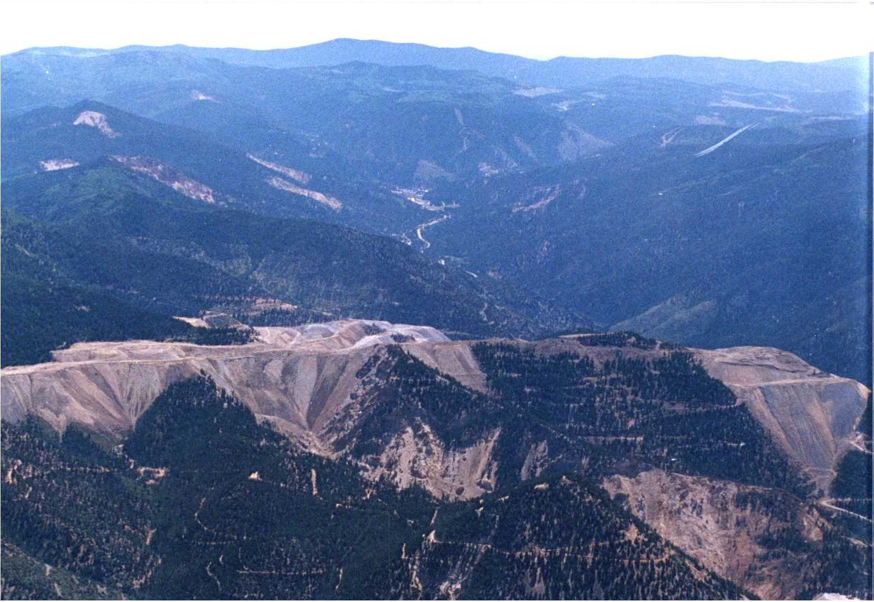
Figure 2 - Questa mine and Red River valley looking eastward. Valley-filling mine rock piles (Capulin, Goathill and Sugar Shack West piles) are shown. Alteration scars (bleached and rugged
outcrop areas) appear both in the foreground and background in this air photo. The town of Red
River is in the Red River valley, east of the mine.

at 2700 TPD, and the average grade of ore in the block currently being mined is 0.38 % MoS₂. At full capacity, the mill can process some 15,000 TPD of ore.

Physiographic Features. The Questa mine is located in the Taos Range of the Sangre do Cristo Mountains in the Southern Rocky Mountain physiographic province. The maximum relief in the Taos Range is over 6,000 feet whereas local relief at the mine is over 3,300 feet. The mine site is located in an area of high relief with elevations varying from 7,580 to 10,812 feet in an area of about 6 square miles. The main headframe of the mine is located on the south-facing slopes of the Red River Valley approximately at 8000 feet above sea level. Two miles west of the Questa mine the Rio Grande rift valley abuts against the mountain range front.

The average gradient of the Red River in the vicinity of the mine is 2 %. Tributary stream valley bottoms now filled by mine rock piles have an average gradient of some 11 % (Schilling, 1956). Red River flows into the Rio Grande River immediately west of Guadalupe peaks and the town of Questa. The incised valleys hosting tributary streams typically have slopes with grades ranging between 2:1 and 1.4:1. Commonly, outcrops of highly eroded, weathered and hydrothermally altered volcanic and intrusive rocks in alteration scars comprise steep, near-vertical slopes in the tributary valleys on the north side of the Red River valley (Figure 2).

Mine rock piles from open pit overburden mining have been deposited into three tributary valleys (Spring Gulch, Sulfur Gulch, and Capulin Canyon shown in Figure 3). Deposition of rock into Sulfur and Spring Gulches was initially as valley fills, followed by end dumping of rock. Capulin deposits were exclusively end-dumped.

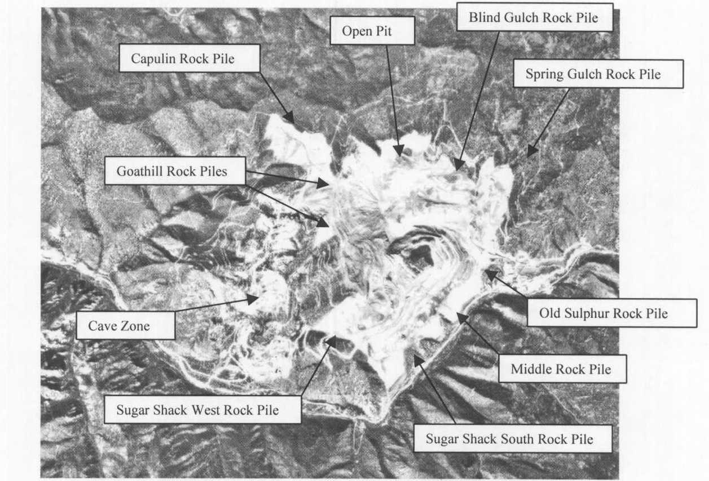

Figure 3 – Air photo (Shaw et al. 2002) of mine site (northward is up in the photo). Mine rock piles, Cave Zone (subsidence zone from block cave mining activity) surround the benched, open pit immediately east of the Goathill Rock Piles. The Red River bounds the south side of mine property.

The subsidence zone (cave zone) from underground block cave mining straddles Goathill Gulch west of the rock piles. Mine rock piles extend vertically from some 8,000 feet to about 9,600 feet in elevation with the result that these piles rank among the highest in North America. Locally, they are up to 350 feet thick. The open pit, cave zone, and individual rock piles are shown in Figure 3.

Climatic Conditions. The climate at the mine is similar to that of the Rocky Mountains of Colorado, but is modified by the semi-arid plateau to the west. The annual precipitation varies from a low of 16.12 inches to a high of 29.01 inches with a 20-year average of 22.84 inches (weather information summarized for the town of Red River, 1975 to 1994). Temperatures vary greatly both annually and diurnally. The average daily maximum temperatures range from 37 to 77 deg. F with average daily minimum temperatures ranging from 6 to 41 deg. F. Freezing temperatures can occur throughout the year. The difference between the minimum and maximum daily temperatures indicates average fluctuations from 28 to 37 degrees.

Hot days and cool nights characterize summer. June through September show average minimum temperatures above 41 deg. F. The rainy season is during July and August. Heavy localized rainfalls during July and August cause flash floods and mudflows, which often block the highway and occasionally damage the mine plant. During the post-28-year construction period, instances of 2- to 4-day periods of thunderstorm activity have transpired in the summer.

Winters are mild, and the roads seldom are blocked by snow. The heaviest snowfall is limited to the higher parts of the mountains. Although the winters are long, protracted periods of freezing weather are limited to December through February. There are many sunny days, and the ground is often bare in areas exposed to the sun. Orographic effects are negligible within the Red River drainage basin. However, greater snow accumulation occurs on the western faces of the Capulin and Goathill North rock piles than on the south-facing slopes.

Geology. The basement rocks in the Taos Range proximal to the Questa mine are comprised of metamorphosed Precambrian ocean floor volcanic and intrusive rocks (1.741 Ga concordia date on zircon; Lipman and Reed, 1989). These rocks are intruded by a quartz monzonite pluton in Cabresto Creek south of the mine site (1.730 Ga concordia age on zircon; Lipman and Reed, 1989). Younger, Middle Proterozoic quartzite (1.713 Ga ²⁰⁷Pb/²⁰⁶Pb date on zircon; Lipman and Reed, 1989) and muscovite-biotite schist crop out on the mine property. Sandstone and conglomerate of late Eocene/early Oligocene age unconformably overlie the Precambrian rocks.

This area has experienced post-Oligocene periods of major eruptive, intrusive, and mountain-building events. Latir volcanic rocks (andesitic and quartz latitic flows, approximately 28 Ma; Bethke and Lipman, 1989) and associated volcanic sandstone crop out in the vicinity of the mine and overlie the Eocene/Oligocene unit. Overlying this Latir sequence is a welded rhyolitic tuff, the 25.7 +/-1 Ma (⁴⁰Ar/³⁹Ar date on sanidine; Czamanske et. al., 1990) Amalia tuff. Eruption of the Amalia tuff concurrently resulted in a caldera collapse event. This caldera is bounded on what is now the southern margin of the Questa caldera by steeply northward dipping caldera-bounding faults--the structural wall of the caldera. Granitic magma subsequently was emplaced along these deeply penetrating faults. The resultant, granitic stocks in the vicinity of the mine have been dated at 24.65 +/- 0.1 Ma and 24.1 +/- 0.1 Ma (⁴⁰Ar/³⁹Ar on biotite; Czamanski et. al., 1990). Mineralizing, hydrothermal solutions evolved from these crystallizing magmas to form zones of mineralization (mostly pyrite with subsidiary molybdenite) that parallel the Red River.

This mid-Tertiary volcanism, intrusive activity and mineralization was associated with the extension of crustal rocks that ultimately resulted in the formation of the Rio Grande rift system. Commencing some19 Ma (?), sediments began to collect in the rift basin from adjacent mountainous areas. Mountain building ceased some 2.5 Ma. A period of mafic-to-acidic volcanism in the rift valley transpired between about 5 Ma and 1.8 Ma.

North of the Red River, many of the valleys contain areas of acid-rock weathered, clay-altered outcrops and cliffs that are typified by high rates of erosion (Figure 4). Locally, blocks of less weathered pyrite bearing
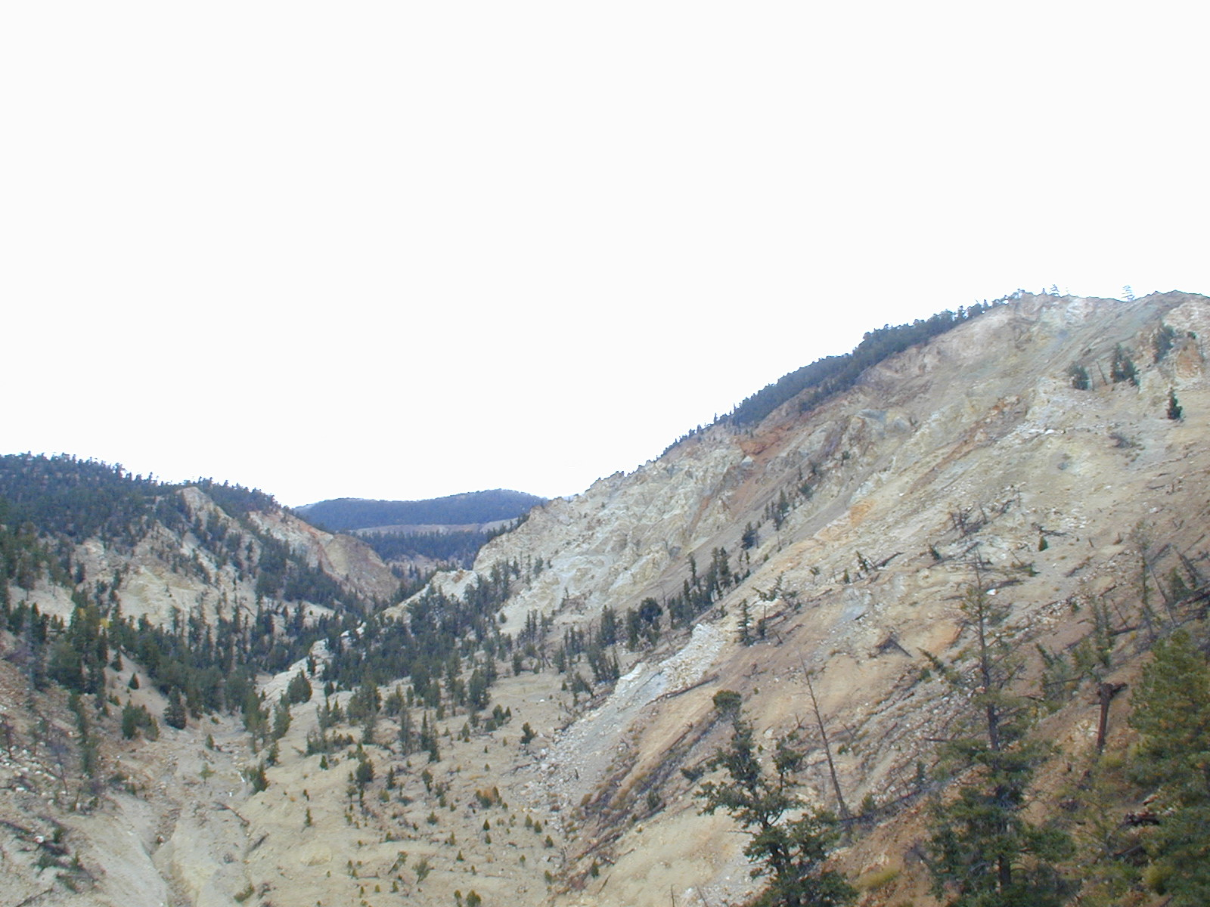

Figure 4 – Goathill Gulch scar area looking northward.

rocks crop out in more weathered, surrounding matrix. Termed alteration scars (also, hydrothermal scars), these features are source areas for debris and mud flows which deposit debris aprons downslope of the scars as far as the Red River, itself (Meyer and Leonardson, 1990). These debris aprons are clay-rich and poorly sorted. Boulder- and gravel-sized clasts typically are matrix supported by clay-to-silt sized sediment. Debris aprons are comprised of pyrite-oxidizing clasts and are a source of significant natural loads of ARD flowing into the Red River.

Previous, On-going, and Future Studies Related to Weathering

“Effective Stress” Strength of Rock Pile Samples. Shear box laboratory tests have been conducted on numerous samples. Effects of particle size have been noted and two populations of data defined based upon percentage of fines (minus #4 sieve) versus friction angle (Robertson GeoConsultants, 2001 report to the Board). The coarser gravels contain less than 40 percent minus # 4 sieve fines. A pronounced stress-dependent envelope curvature develops at even modest maximum stresses, and friction angle increase with fines content. The other type of material (>= 40 % minus # 4 sieve) demonstrates a decrease in friction angle with increasing fines. Production of fines due to geochemical effects in conjunction with stress-milling and slaking effects conceivably will increase the amount of fines in the rock piles. Additional triaxial strength testing is scheduled for this summer.

Cohesion properties likewise may be affected by geochemical weathering. The formation of clays will
undoubtedly affect unsaturated water movement through the rock piles (0 – 12 % moisture in boreholes, Shaw et. al. 2002). Currently, plans are in place to conduct consolidated, undrained triaxial tests with pore pressure measurements to develop effective stress strength parameters.

Inclinometer Installation and Monitoring Program. Inclinometers will be constructed in rock pile boreholes this summer and they will be monitored. Geochemical weathering effects may show up as a change in the rate of rock pile mass displacement with time.

Static Liquefaction Flowsliding. Static liquefaction produces large-volume, high-velocity flowslides with substantial run-out distances. The failure mechanism results from the development of near saturated to saturated conditions often near the base of a pile. The Board recognizes the significance of extreme storm events and flowsliding. Since an extreme storm event is unpredictable, the Board has recommended that the relationship between debris flow formation from scars and past storm events be identified. This would provide a sense of frequency and size of these events, and thereby define a possible long-term design parameter for potential re-sloping and run-off controls. A U.S. Geological Survey geomorphologist currently is mapping the debris aprons to define the frequency of mudflow events throughout the Recent geologic history recorded in the debris aprons. Currently, projects are underway to control storm runoff events proximal to and on mine rock piles.

Historic Rock Pile Topographic and Settlement Evaluations. This work involves the evaluation of current rock pile settlement. Comparison of the current rock pile topography with earlier topographic surveys of rock piles will be conducted in order to assess settlement processes over time. Additionally, the current monitoring program of slope movement will continue, and the observation and documentation of cracking will continue.

Identify Existing Man-made Historic Rock Pile Analogs. The Board has expressed an interest in determining long-term effects of pyrite-oxidation and acidification processes on clay formation by examining historic rock pile analogs to Questa mine rock pile performance characteristics. Natural and man-made analogs can be investigated for any evident presence or effects of clays produced by long-term oxidation and acidification processes. These could include acid generating in existence for many centuries at ancient mines in Europe and Scandinavia, and hydrothermal ore deposits in mature stages of sulfide-to-oxide conversion. This work will begin fall 2002.

Clay mineralogy. The Board has provided information and recommendations relative to investigating clay mineralogy. This work has begun and includes determination of clay minerals from rinse water compositions by plotting these compositions on the appropriate activity diagrams. In addition, a mineralogical analysis (by X-ray Diffraction/Reitveld analysis and PIMA spectral analysis) of hydrothermally altered, pyrite-bearing rocks in scars and ore system outcrops has begun in order to determine whether or not these rocks contain clays. The final recommendation of the Board is to calculate the maximum volume percent of rock that might consist of clay minerals based upon the conversion of feldspars to clay in the presence of sulfuric acid generated by the oxidation of pyrite by the reaction

FeS₂ + 15/4 O₂ + 5/2 H₂O = FeOOH + 4H⁺ + 2SO₄²⁻

A geochemical baseline must be defined for clay minerals formed by hydrothermal alteration and by natural weathering processes. Alteration scar features are present for some eleven miles along the northern reaches of the Red River valley from the range front to Bitter Creek northeast of the town of Red River. All of these scar features contain pyrite and presumably have undergone prolonged infiltration of highly acidic water over time. Significant amounts of clay are contained in acid-generating debris aprons. Whether or not the formation of clays by weathering is a near surface process with clay production and erosion in near balance remains to be determined.

Geochemistry. Pyrite- and minor molybdenite-mineralized andesite, aplite porphyry, andesite-to-quartz-latite porphyry flows, and welded rhyolite tuff rock aggregate comprise the rock piles on mountain slopes and valleys proximal to the open pit. Soil-like, acid-weathered, clay-rich equivalents of these rock types (from scar material) also are present on these piles. Colluvium, overlying acid weathered outcrops above the pit (Sulfur Gulch scar), has many of the physical appearances of debris flow aprons. This colluvial material was stripped and placed upon the dumps.

Pyrite content in debris apron clasts averages some 2% by volume with as much as 5 %, locally. Molybdenite concentrations are less than 0.09 % by weight. Acid generation (H₂SO₄) is known to occur as a result of the oxidation of pyrite. The incipient definition and quantification of geochemical processes associated with acid rock weathering processes has been a recent focus of studies conducted by Molycorp’s consultants. However, different interpretations of rates and magnitudes of geochemical processes have resulted in uncertainties associated with quantitative predictions of weathering rates of rock aggregate due to relatively unknown mineralogical and geochemical variabilities in the rock piles.

Investigations into physical modifications of rock pile particles due to geochemical changes have yet to be initiated. Fabric and structure of the piles, effect of weathering and particle degradation upon shear strength, changes in rock pile hydraulic conductivity and oxygen content, and the effect of clays and of precipitate formation on surficial boundary conditions on the dumps are issues to be quantitatively defined and ultimately investigated. A goal of these studies is to predict the stability factors and risk associated with various geochemical and extreme climatic conditions projected into the future.

Letter of Intent

Molycorp requests that qualified university researchers and research groups submit a Letter of Intent to Molycorp Inc. for the purpose of being chosen by Molycorp to subsequently submit a Research Proposal. The Letter of Intent shall include the following:

- A description of the general approach to develop a model that assesses the risk of physical failure of existing mine rock piles based on the physical, chemical, and mineralogical composition and weathering of the rock piles.
- A statement of the basis of the researcher’s (or research group’s) interest and team work-related qualifications;
- The researcher’s Résumé (a research group must submit the résumé’s of individuals who are qualified to conduct the research);
- The researcher’s Bibliography (or, bibliographies of qualified researchers in a research group) with pertinent, stability-related publications highlighted;
- A description of Research Facilities available to the researcher or research group (indicate availability of these facilities);
- The number of graduate or post-graduate students typically supervised for research projects;
- If available, a list of the types of graduate students typically available to conduct the research, their qualifications, and degree pursuit;
- A description of current and on-going research commitments, and percentage of time researcher will have available for this project; and
- A description of university overhead policies for industry-funded research.

Letters of intent should be submitted not later than 11 October 2002 to:

Dr. Bruce Walker
Molycorp, Inc.
Molybdenum Group
P.O. Box 469
Questa, NM 87556-0469
Telephone: 505/586-7628
Facsimile: 505/586-0811
Email: bmwalke@molycorp.com

Research Proposal Development

Subsequent to the selection of qualified researchers based upon their Letter of Intent, Molycorp Inc. will request that each of these qualified individuals or groups attend a site meeting and subsequently submit a Research Proposal. Possible research topics to address in the Research Proposal include (but are not limited to):

- The character of weathered and unweathered bedrock and rock pile occurrences of clays;
- The rates of weathering of both bedrock and rock pile fragments;
- The mechanisms of weathering of bedrock and of rock pile fragments;
- The changes in rock pile structure over time;
- The definition of water pathways in rock piles;
- The changing character of water movement through rock piles over time; and
- The effect of changing rock pile chemical, mineralogic, and physical conditions upon the mechanical properties of the rock piles.

It is the company’s intention and hope that predictive, rock pile stability models will result from this research.

Proposal Selection

Molycorp will select proposals for 2003 funding in February 2003.

Molycorp Mine Resources Available to Researchers

Molycorp’s Questa mine has significant resources available assist researchers with on-site support of research activity.

- Heavy equipment and operators-- this includes bulldozers and backhoes.

- Professional staff support and expertise, including engineers, geologists (economic and geotechnical), chemists and geochemists

- Cuttings from 23 monitoring wells and boreholes

- Lysimeters, weather stations, and instrumented boreholes on mine rock pile sites

- Geologic and geotechnical well logs

- Some 750,000 feet of drill core and associated core logs

- Libraries containing company and consultant’s reports, theses (Masters and Ph.D.), maps, and cross sections

- Maintained road access on mine rock piles

- Survey controls

Suggested Site-specific References

Bethke, M.M. and Lipman, P.W., 1989, Questa caldera and associated porphyry molybdenum
mineralization, Latir volcanic field, Sangre de Cristo mountains, and Rio Grande rift, in Mineralization in Silicic Calderas: Questa, New Mexico and the San Juan Mountains, Colorado: Washington, DC, American Geophysical Union, Field Trip Guidebook T320, p. 1 – 15.

Czamanski, G.K., Foland, K.A., and Allen, J.C., 1990, The ⁴⁰Ar/³⁹Ar chronology of caldera formation,
intrusive activity and Mo-ore deposition near Questa, New Mexico, in Tectonic development of the Southern Sangre do Cristo Mountains, New Mexico: New Mexico Geological Society Guidebook, 41st Annual Field Conference, p. 355-358.

Lipman, P.W. and Reed, J.C., 1989, Geologic map of the Latir volcanic field and adjacent Areas, Northern
New Mexico: USGS Miscellaneous Investigations Series Map I-1907.

Meyer, and Leonardson, R., 1990, Tectonic, hydrothermal and geomorphic controls on alteration scar
formation near Questa, New Mexico, in Tectonic development of the Southern Sangre do Cristo Mountains, New Mexico: New Mexico Geological Society Guidebook, 41st Annual Field Conference, p. 417-422.

Shaw, S., Wels, C., Robertson, A. 2002, Physical and geochemical characterization of mine rock piles at
the Questa mine, New Mexico: An overview, in Proceedings of the Tailings & Mine Waste ’02 Conference, January 27-30, Fort Collins, CO.

Wels, C., Loudon S. and Fortin, S., 2002, Factors influencing Net Infiltration into Mine Rock Piles at
Questa mine, New Mexico, in Proceedings of the Tailings & Mine Waste ’02 Conference, January 27-30, Fort Collins, CO.

Molycorp Inc. maintains a website with links to pertinent geotechnical, and other, company manuscripts. This website is found at the following address:

http://www.molycorp.com

